How To Write to a Penpal

- The first letter doesn't need to be too long. It is just a way to introduce yourself and a way to get the conversation started.
  - Include things such as….
    - What's your name? (First name only)
    - Age?
    - Family size?
    - Hobbies?
    - Interests?
    - Pets?
    - Some of your favorite things?
    - Things that have been difficult? Things that have helped you recently?
    - Why do you want a penpal?
- Make sure to always ask questions. This gives them something to respond to.
- Always tell the truth
- Finish your letter in a way that leaves things open and invites a reply. For example, “I look forward to getting to know you better and I hope to hear from you soon”.
- Sign off with something cheerful that promotes friendships , e.g. “Your friend” or “Kind regards” and then your first name.
RULES
- No flirting
- No discussion of violence
- No sexual conversations
- No discussion of drugs
- No sharing of personal information-First names only
-No finding each other on social media
*You will receive a warning if these rules are broken and asked to rewrite the letter.

- Have FUN! This is your time to be yourself and learn how to connect with others. You will find that others may be experiencing similar things. You are not alone!
- Start your first letter and mail it to the address below...
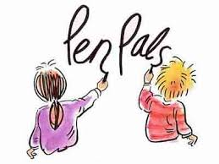
Write all letters to:
Family Solutions Counseling
ATTN: Pen Pal Program
115 Golf Course Road Suite E
Logan,UT 84321

If you have any questions or concerns, please contact our office 435-799-5035

